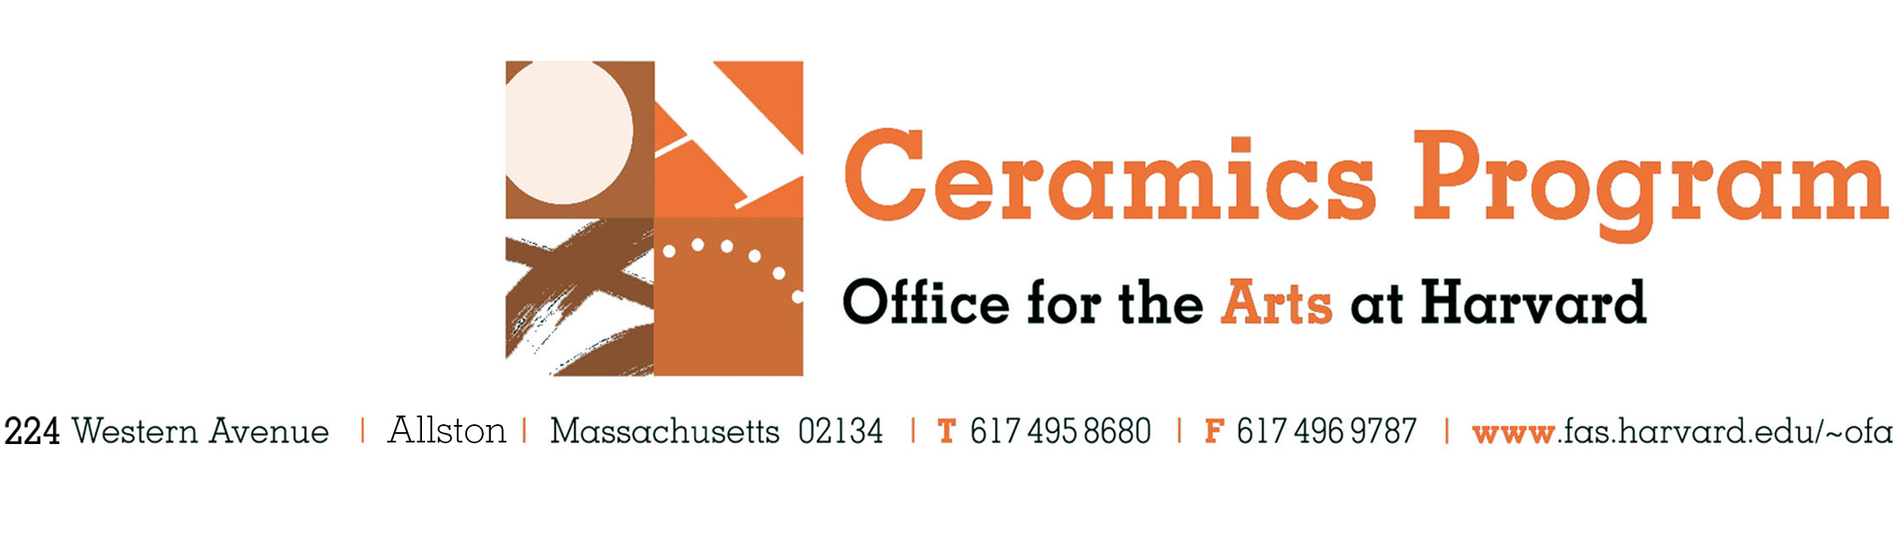
Ceramics Program Work Exchange Application Form

Please read the Ceramics Program Work Exchange information on our website, complete this application form and submit it to Kathy King at kking@fas.harvard.edu with your application materials.

Contact Information
Name _______________________________________________________________________________________________

Address_____________________________________________________________________________________________

City _____________________________________________ State _________________ Zip _______________________
Phone_____________________________________ Email ____________________________________________________
Current School/ Work information
Degree/Major: ________________________________________________ Year: ______________________________
School or Schools: ___________________________________________________________________________________
Company: _________________________________________________________________________________________
Title: ______________________________________________________________________________________________
References

Name_________________________________________________________ Email ________________________________

Title/Organization______________________________________________Phone________________________________

Name_________________________________________________________ Email ________________________________

Title/Organization______________________________________________Phone________________________________

Application checklist
- Resume
- Cover letter
- Contact information for (2) references, professional and/or academic
- Images of work
________________________________________________________________________________________________

