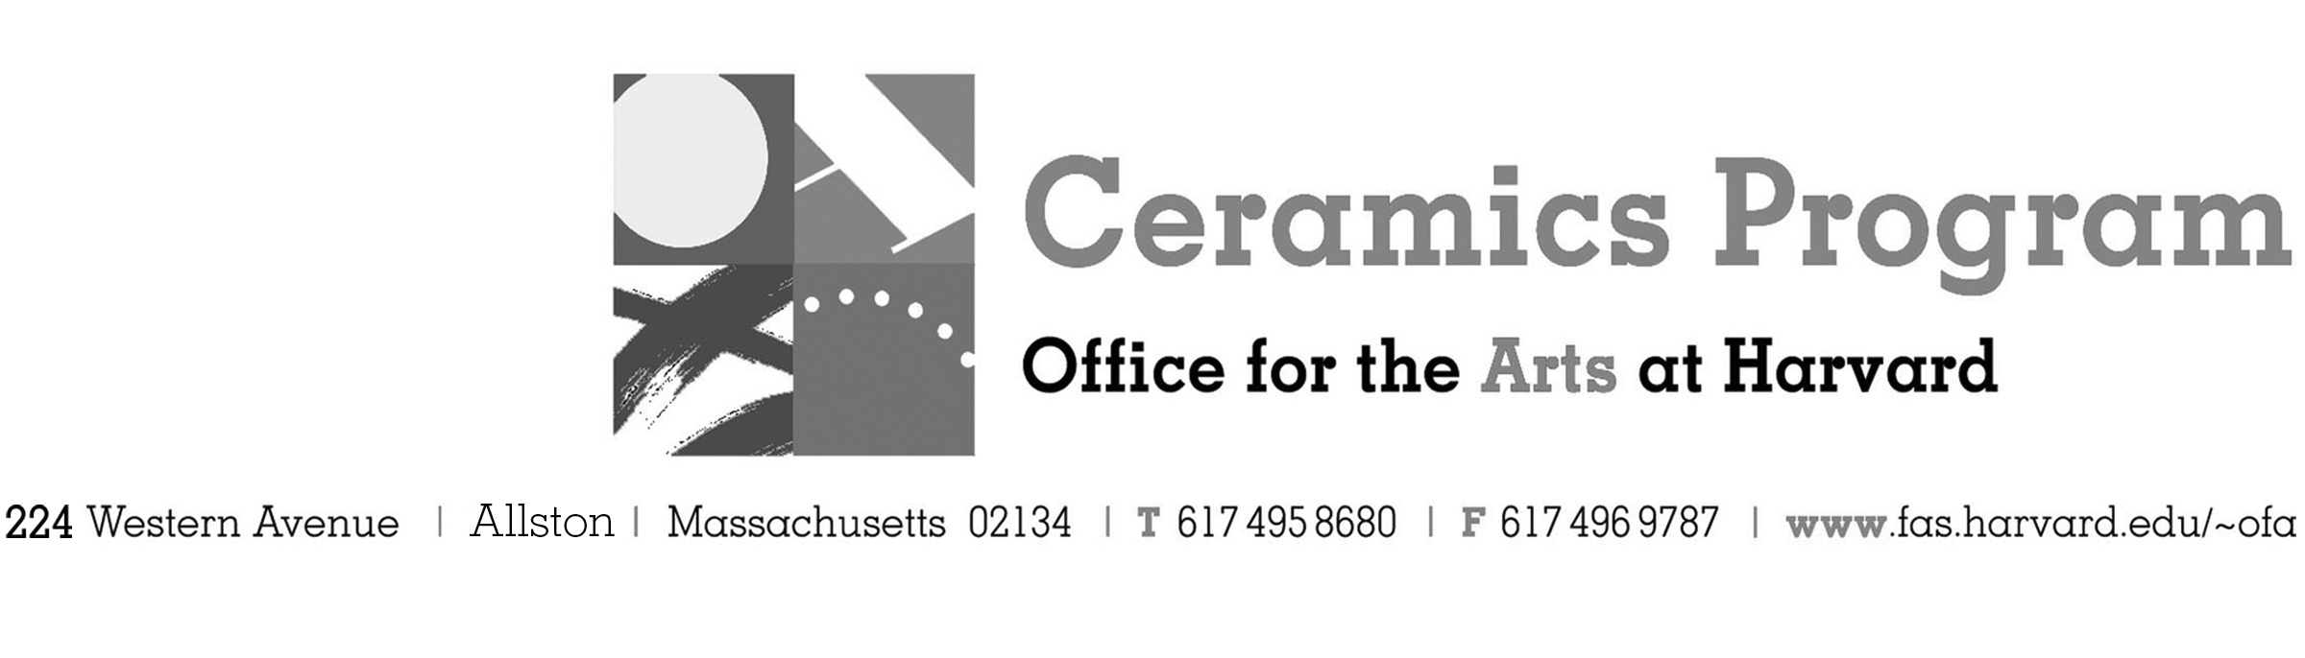

Wintersession: Hand Made Mugs

Wintersession 2018

Workshop Dates Tuesday, January 15 – Friday, January 19th, 2pm – 5pm each day

Registration Please fill out this form and send to Shawn Panepinto, panepint@fas.harvard.edu or call 617-495-8680.

Description Stuart Gair, Instructor and Artist in Residence, Ceramics Program, Office for the Arts at Harvard
Whether it is for morning coffee, noon soup, or evening hot chocolate, if you want to exchange the Styrofoam and paper versions for a handmade, ceramic mug, this workshop is for you. Along with being introduced to the potter’s wheel, you will also acquire basic skills in hand forming basic shapes – like a mug! This is a great opportunity to try clay and to gain an excellent foundation for further exploration. This workshop is for students of all levels. A special session will be arranged for you to glaze your work during the Spring Term.
Enrollment: 20

- Please fill out this form and send to Shawn Panepinto, panepint@fas.harvard.edu or call 617-495-8680.
- Send or bring this registration form to the studio:
Ceramics Program, Visiting Artist Workshop, 224 Western Ave. Allston, MA 02134

Workshop | Total Fee
Wintersession Hand Mage Mugs with Stuart Gair | $N/A
 | $
Workshop Fee | $N/A

Contact
Name (please print)
Address City
State Zip E-mail Address
Telephone (day) (cell)
Harvard: Undergraduate Graduate

