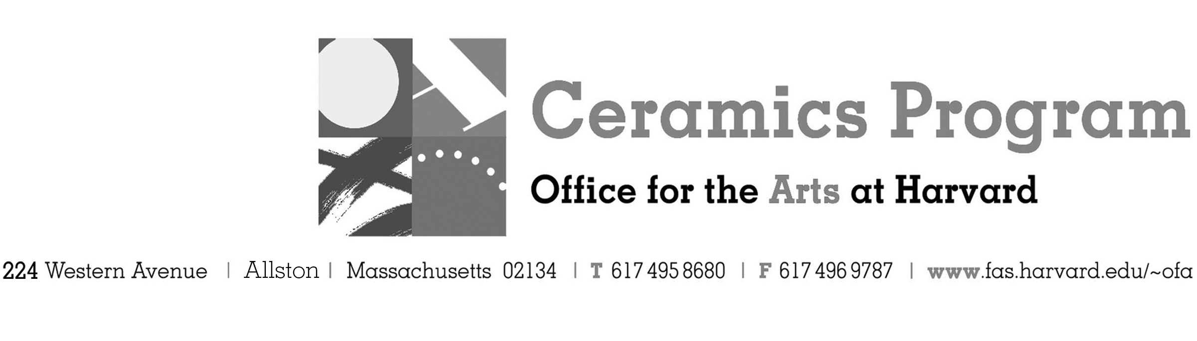

Visiting Artist Workshop: Justin Rothshank

Fall Term 2016 14 week term: August 29 – December 3, 2016

Workshop Dates Thursday, October 13, 10:00 am – 5:00pm

Fees Enrolled in a course, $125. Not enrolled, $225. Harvard Graduate, $50. Free for Harvard Undergraduate

Description In this workshop, Justin Rothshank will focus on making his own ceramic forms on the wheel. He will then introduce how to transfer imagery onto ceramic work using a laser printer and decal paper. An overview of image preparation, printing decals onto decal paper, transferring decals onto greenware and glazed ware, layering of decals, using commercial decals, and firing temperatures for various types of decals. You will learn how to use and fire decals in all kinds of kilns, and we'll specifically talk about electric kilns and soda kilns.

Total registration fee and Harvard employee TAP form, if used, must be submitted with the registration form. We can accept payment in cash, check or money order. We do not accept credit cards.

- Make check or money order for workshop fees payable to Harvard University.
- Send or bring this registration form, payment and a TAP form if applicable, to the studio:
Ceramics Program, Visiting Artist Workshop, 224 Western Ave. Allston, MA 02134

Workshop | Total Fee
Justin Rothshank Visiting Artist Workshop | $
 | $
Workshop Fee | $

Contact Name (please print)
Address City
State Zip E-mail Address
Telephone (day) (cell)
Enrolled in a class Not enrolled in a class
Harvard Employee: TAP eligible: regular Long service not TAP eligible
Harvard: Undergraduate Graduate Class of____ School/ Depart. at Harvard: _________________
Harvard Affiliation: Alum Extension School Student Spouse of Harvard Employee

for studio use only: Date received Check # Amount $ TAP form

