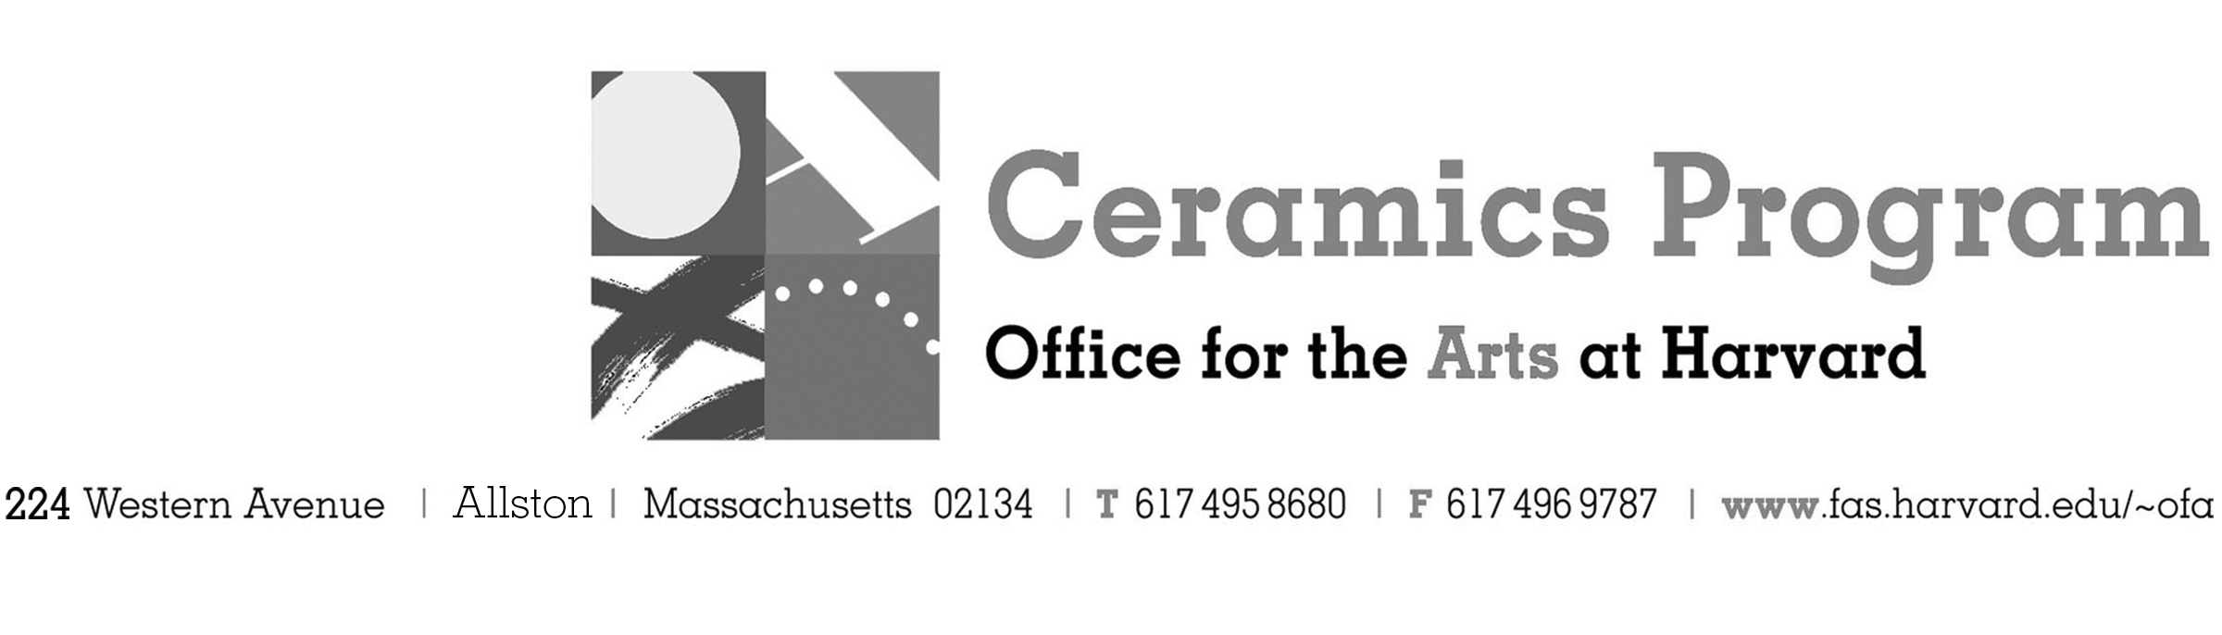

Visiting Artist Workshop: Don Reynolds

Summer Term 2017

Workshop Dates Monday, July 24th, 1:00pm – 5:00pm

Fees Enrolled in a course, $25. Not enrolled, $50. Free for Harvard Undergraduate and Graduate Students.

Description Join us in welcoming one of the most colorful personalities in clay, Don Reynolds, who hails from the Clay Art Center in Port Chester, NY. Reynolds tries to never produce pots that will match the sofa – unless you live in Pee Wee’s Playhouse. Driven by color, pattern and textures, Reynolds will demonstrate surface techniques using underglaze and wax that provide his distinctive bold surfaces. This workshop is perfect for those looking for a new direction for their work or interested in layering techniques using bright color that both sing and dance!

This workshop will feature a slide presentation by both artists beginning at 5:30pm.

- Make check or money order for workshop fees payable to Harvard University.
- Send or bring this registration form, payment and a TAP form if applicable, to the studio:
Ceramics Program, Visiting Artist Workshop, 224 Western Ave. Allston, MA 02134

Workshop | Total Fee
Don Reynolds Visiting Artists Workshop | $
 | $
Workshop Fee | $

Contact Name (please print)
Address City
State Zip E-mail Address
Telephone (day) (cell)
Enrolled in a class Not enrolled in a class
Harvard Employee: TAP eligible: regular Long service not TAP eligible
Harvard: Undergraduate Graduate Class of____ School/ Depart. at Harvard: _________________
Harvard Affiliation: Alum Extension School Student Spouse of Harvard Employee

for studio use only: Date received Check # Amount $ TAP form

