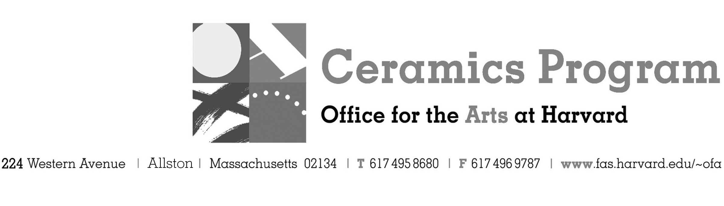

Visiting Artist Workshop: Kyungmin Park

Spring Term 2017 14-week term: January 30 – May 6, 2017

Workshop Dates Saturday, March 4, 10:00 am – 5:00pm

Fees Enrolled in a course, $75. Not enrolled, $125. Harvard Graduate, $50. Free for Harvard Undergraduate Students.

Description Sculptor Kyungmin Park will demonstrate the construction of her figurative sculptures in porcelain in this one-day workshop. Park will demonstrate how to achieve crisp lines and clean, tight surfaces with simple tools. She will also explore conceptual ideas and talk about the importance of facial expression and symbology within her work.

Total registration fee and Harvard employee TAP form, if used, must be submitted with the registration form. We can accept payment in cash, check or money order. We do not accept credit cards.

- Make check or money order for workshop fees payable to Harvard University.
- Send or bring this registration form, payment and a TAP form if applicable, to the studio:
Ceramics Program, Visiting Artist Workshop, 224 Western Ave. Allston, MA 02134

Workshop | Total Fee
Kyungmin Park Visiting Artist Workshop | $
 | $
Workshop Fee | $

Contact Name (please print)
Address City
State Zip E-mail Address
Telephone (day) (cell)
Enrolled in a class Not enrolled in a class
Harvard Employee: TAP eligible: regular Long service not TAP eligible
Harvard: Undergraduate Graduate Class of____ School/ Depart. at Harvard: _________________
Harvard Affiliation: Alum Extension School Student Spouse of Harvard Employee

for studio use only: Date received Check # Amount $ TAP form

