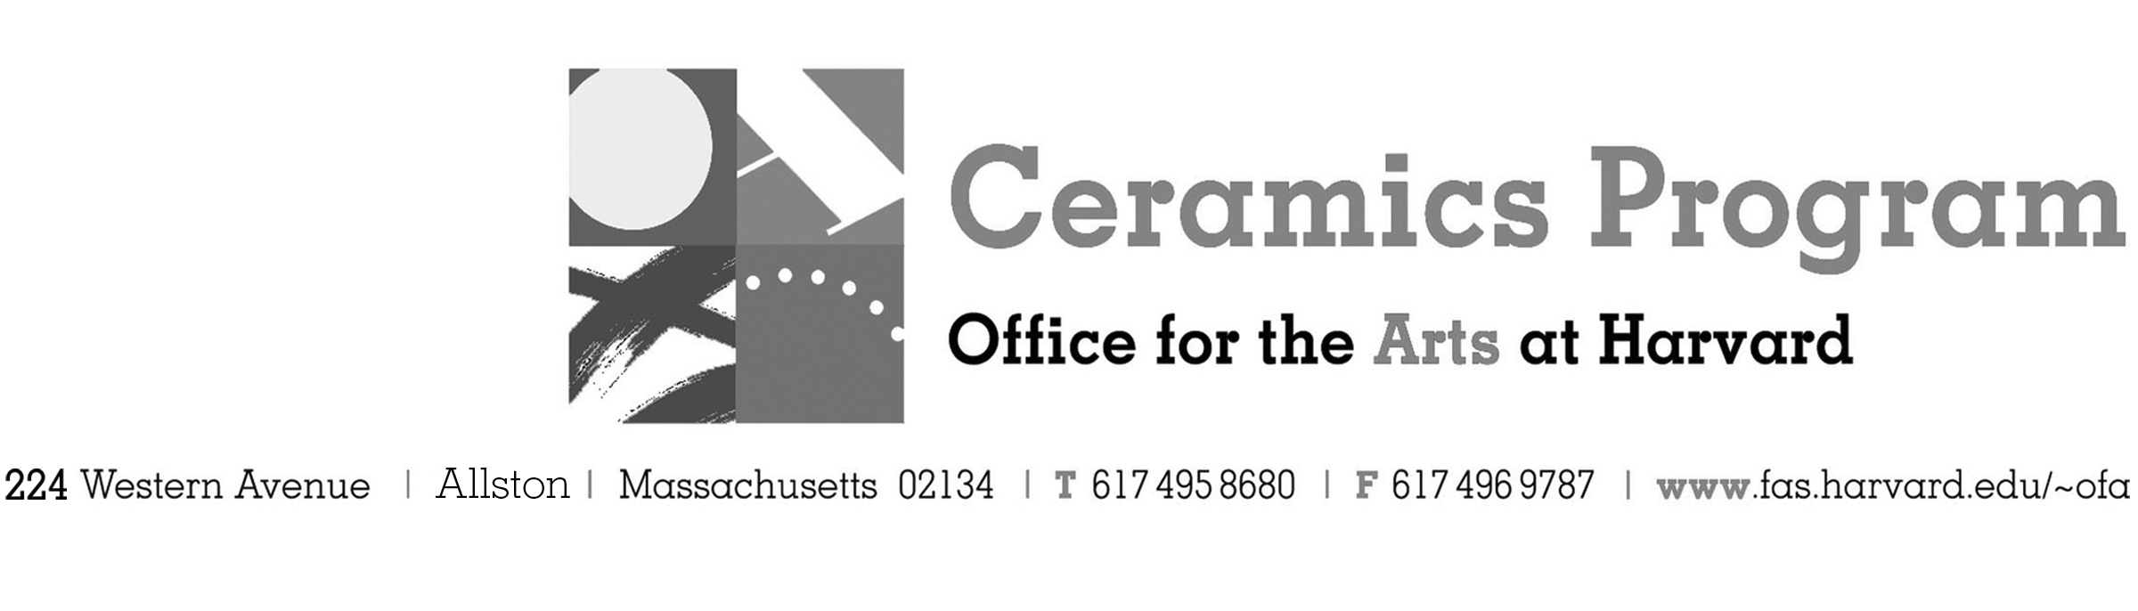

Visiting Artist Demonstration: Bai Ming

Fall Term 2017 14-week term: August 28 – December 2, 2017

Date Friday, November 10, 10:00 am – 4:00pm

Fees Enrolled in a course, $25. Not enrolled, $50. Harvard Graduate, $25. Free for Harvard Undergraduate Students.

Description Bai Ming is today an acknowledged artist whose activity as plastics technician and teacher contributes in renewing and revitalizing deeply the Chinese contemporary creation in the field of ceramics. He mixes traditional techniques and ancestral typologies to the most modern plastic expressions. In the pictorial field, he uses oil painting as well as ink, in an eclectic style which alternates geometrical compositions and gestural practices. This demonstration coincides with Bai Ming's visit to the Boston area for his solo exhibition at the Lacoste Gallery in Concord, MA.

Total registration fee and Harvard employee TAP form, if used, must be submitted with the registration form. We can accept payment in cash, check or money order. We do not accept credit cards.

- Make check or money order for workshop fees payable to Harvard University.
- Send or bring this registration form, payment and a TAP form if applicable, to the studio:
Ceramics Program, Visiting Artist Workshop, 224 Western Ave. Allston, MA 02134

Workshop | Total Fee
Bai Ming Visiting Artist Demonstration | $
 | $
Workshop Fee | $

Contact Name (please print)
Address City
State Zip E-mail Address
Telephone (day) (cell)
Enrolled in a class Not enrolled in a class
Harvard Employee: TAP eligible: regular Long service not TAP eligible
Harvard: Undergraduate Graduate Class of____ School/ Depart. at Harvard: _________________
Harvard Affiliation: Alum Extension School Student Spouse of Harvard Employee

for studio use only: Date received Check # Amount $ TAP form

