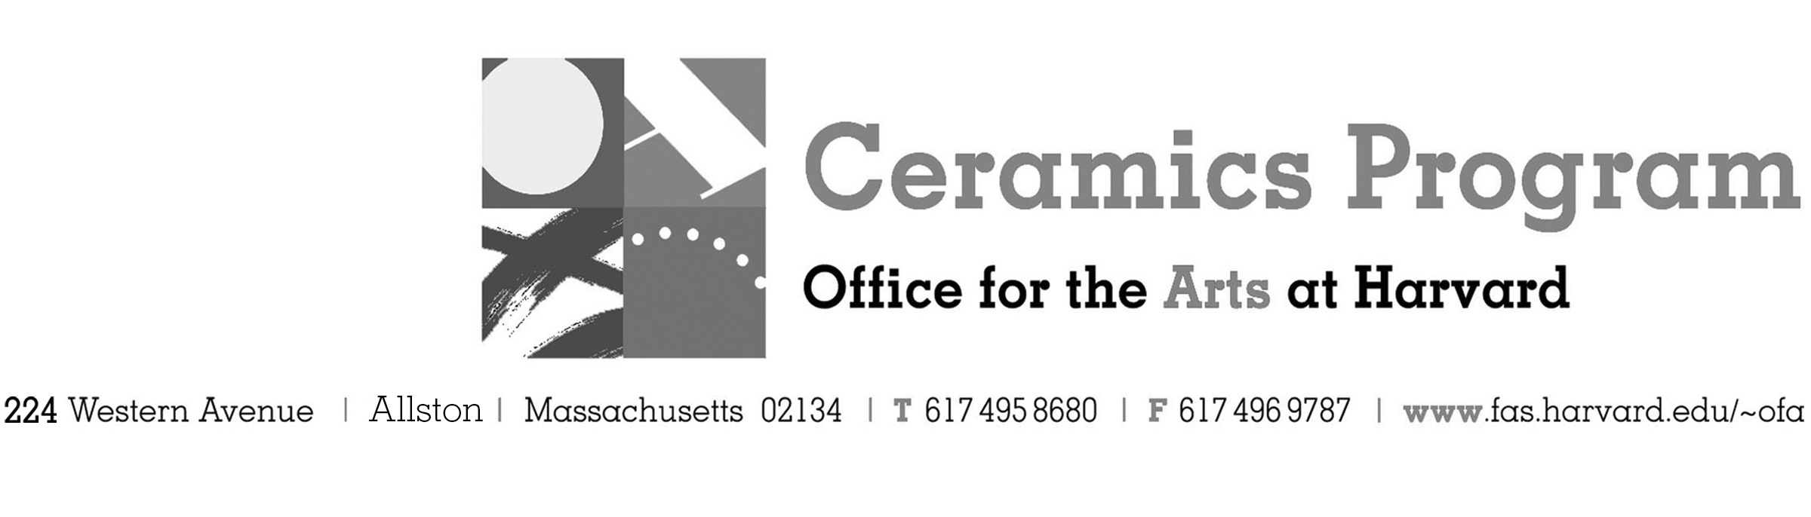

Visiting Artist Workshop: Tom Jaszczak and Mike Helke

Summer Term 2017

Workshop Dates Friday, August 4th, 10:00 am – 5:00pm

Fees Enrolled in a course, $75. Not enrolled, $125. Harvard Graduate, $50. Free for Harvard Undergraduate Students.

Description Join us for a two-person demonstration by Mike Helke and Tom Jaczczak prior to their joint exhibition at Lacoste Gallery in Concord, MA on August 5-26. Both artists explore the vessel in very distinctive ways – Jaszczak celebrates utility through his sublime soda-fired, earthenware forms. His surfaces are inviting with bold graphic lines and bright color contrast the slip covered surface. Helke creates bold form that play with the senses – working within two and three dimensions, appearing at times completely flat, only to reveal its volume as you when you handle and experience the work directly.

This workshop will feature a pot-luck lunch from 1-2pm as well as a slide presentation by both artists beginning at 5pm.

- Make check or money order for workshop fees payable to Harvard University.
- Send or bring this registration form, payment and a TAP form if applicable, to the studio:
Ceramics Program, Visiting Artist Workshop, 224 Western Ave. Allston, MA 02134

Workshop | Total Fee
Tom Jaczczak and Mike Helke Visiting Artists Workshop | $
 | $
Workshop Fee | $

Contact Name (please print)
Address City
State Zip E-mail Address
Telephone (day) (cell)
Enrolled in a class Not enrolled in a class
Harvard Employee: TAP eligible: regular Long service not TAP eligible
Harvard: Undergraduate Graduate Class of____ School/ Depart. at Harvard: _________________
Harvard Affiliation: Alum Extension School Student Spouse of Harvard Employee

for studio use only: Date received Check # Amount $ TAP form

