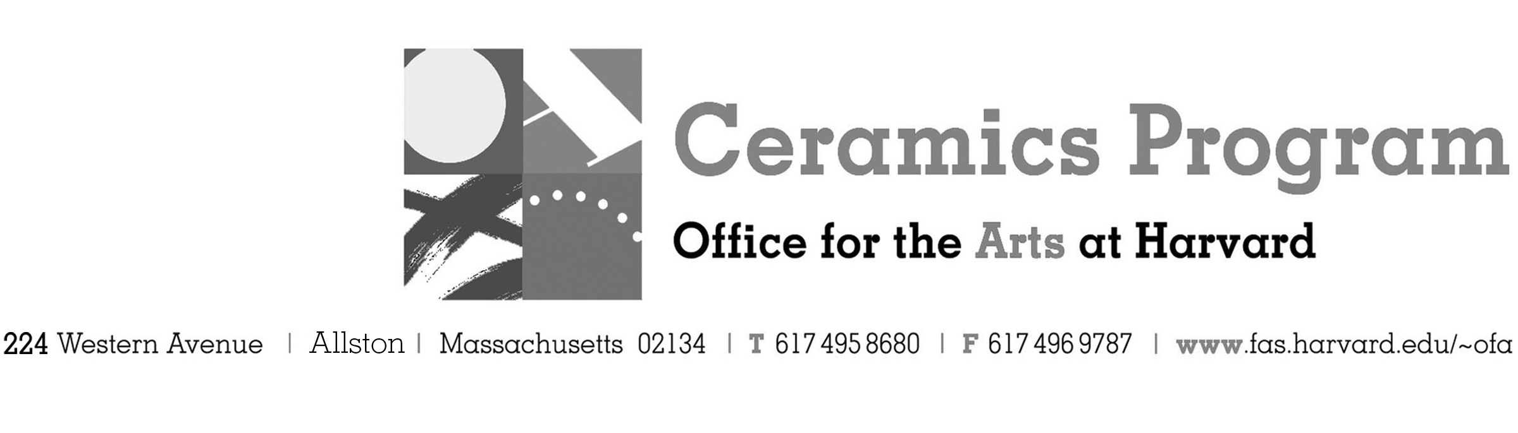

Visiting Artist Workshop:

Israel Davis and Salvador Jiménez Flores

Fall Term 2016 14 week term: August 29 – December 3, 2016

Workshop Dates Saturday, September 10, 10:00 am – 5:00pm

Fees Enrolled in a course, $125. Not enrolled, $225. Harvard Graduate, $50. Free for Harvard Undergraduate

Description In celebration of Salvador Jiménez-Flores' exhibition in Gallery 224 to mark the end of his 2015-2016 residency with the Ceramics Program, Salvador and his former professor, mentor and friend Israel Davis will come together for this one-day workshop. Join us for an in-depth look at utilizing traditional printmaking techniques such as silk-screening onto the ceramic two-dimensional and three-dimensional surface. There will be a hands-on component to the workshop to allow participants to try the techniques first-hand. Colorful and expressive surfaces and lively conversation make this a "must-see" event!

Total registration fee and Harvard employee TAP form, if used, must be submitted with the registration form. We can accept payment in cash, check or money order. We do not accept credit cards.

Individuals with disabilities seeking accommodations or with any questions should contact Shawn Panepinto at 617.495.8680 or by e-mail at panepint@fas.harvard.edu

- Make check or money order for workshop fees payable to Harvard University.
- Send or bring this registration form, payment and a TAP form if applicable, to the studio:
Ceramics Program, Visiting Artist Workshop, 224 Western Ave. Allston, MA 02134

Workshop | Total Fee
Israel Davis and Salvador Jiménez Flores Visiting Artist Workshop | $
 | $
Workshop Fee | $

Contact Name (please print)
Address City
State Zip E-mail Address
Telephone (day) (cell)
Enrolled in a class Not enrolled in a class
Harvard Employee: TAP eligible: regular Long service not TAP eligible
Harvard: Undergraduate Graduate Class of____ School/ Depart. at Harvard: _________________
Harvard Affiliation: Alum Extension School Student Spouse of Harvard Employee

for studio use only: Date received Check # Amount $ TAP form

