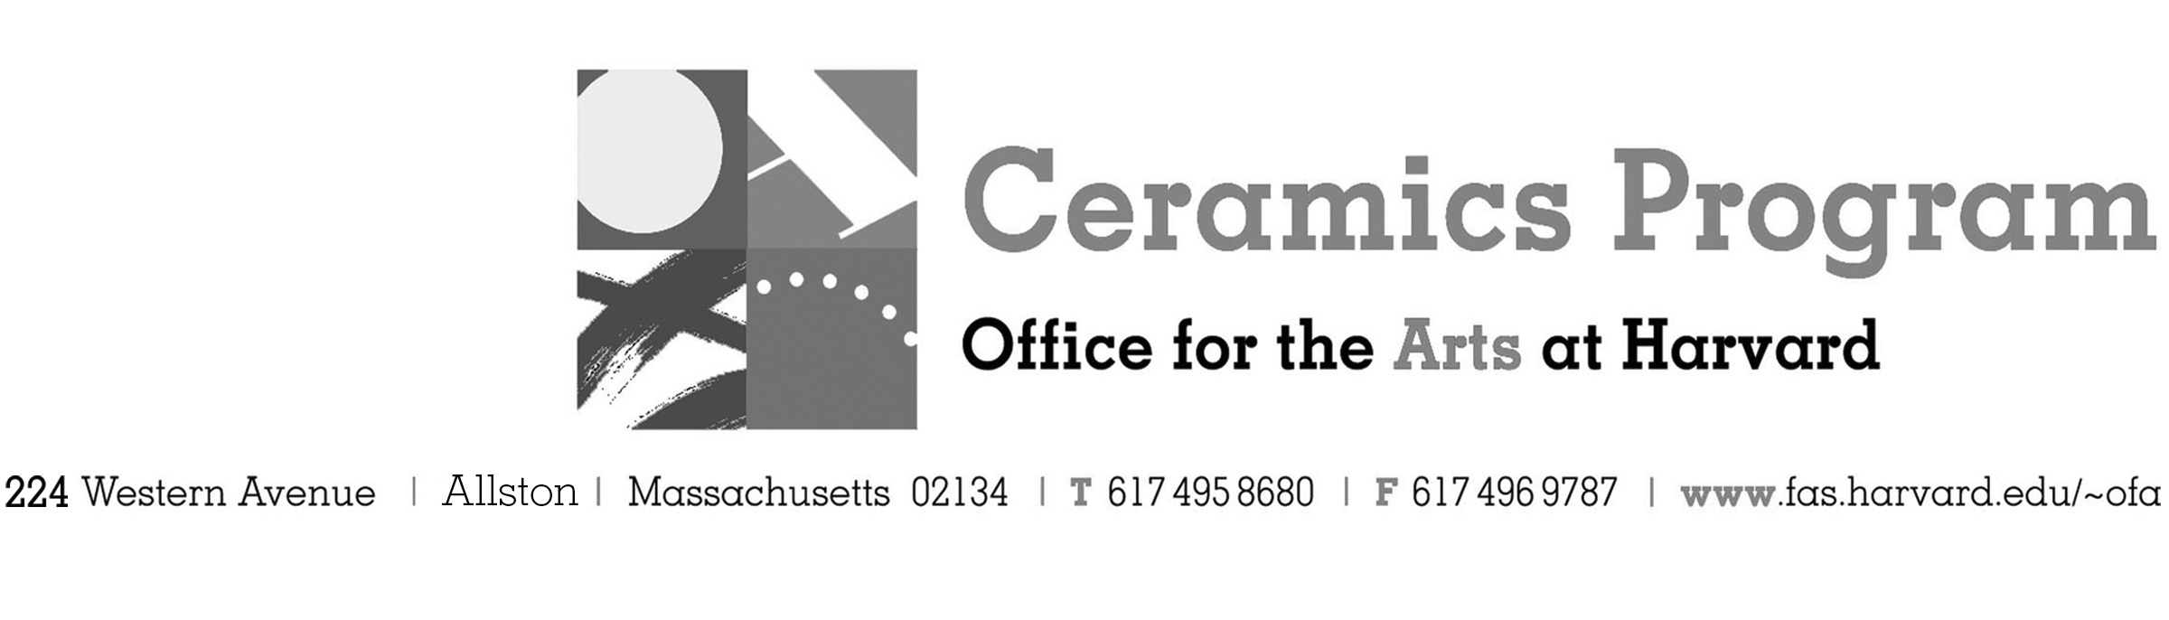

Visiting Artist Workshop: Phoebe Cummings

Summer Term 2017

Workshop Dates Wednesday July 19th, 10:00am – 4:00pm

Fees Enrolled in a course, $25. Not enrolled, $50. Free for Harvard Undergraduate and Graduate Students.

Description During this workshop you will work with artist Phoebe Cummings from the UK, to explore the potential of sprig molding and hand building techniques. Two-dimensional designs will be used as a starting point to create simple press molds, from which you will construct and adapt into more elaborate three-dimensional forms. This class will consider relationships between historic design and contemporary sculpture. An artist talk will also be held at lunch time; lunch will be potluck for those who wish to bring a dish to share.

- Make check or money order for workshop fees payable to Harvard University.
- Send or bring this registration form, payment and a TAP form if applicable, to the studio:
Ceramics Program, Visiting Artist Workshop, 224 Western Ave. Allston, MA 02134

Workshop | Total Fee
Phoebe Cummings Visiting Artist Workshop | $
 | $
Workshop Fee | $

Contact Name (please print)
Address City
State Zip E-mail Address
Telephone (day) (cell)
Enrolled in a class Not enrolled in a class
Harvard Employee: TAP eligible: regular Long service not TAP eligible
Harvard: Undergraduate Graduate Class of____ School/ Depart. at Harvard: _________________
Harvard Affiliation: Alum Extension School Student Spouse of Harvard Employee

for studio use only: Date received Check # Amount $ TAP form

