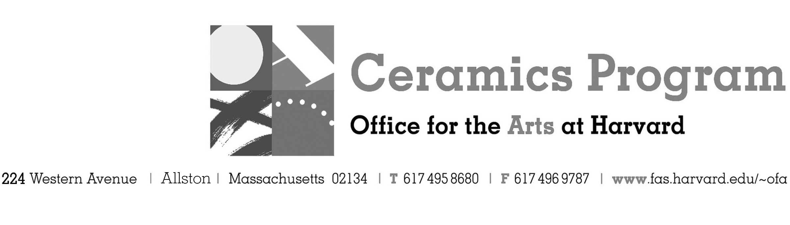

Visiting Artist Workshop: Darcy Badiali

Spring Term 2017

Workshop Dates Friday, May 5, 10:00 pm – 4:00pm

Fees Enrolled in a course, $0. Not enrolled, $25. Free for Harvard Graduate and Undergraduates.

Description Join us for a one-day workshop and demonstration by California-based artist Darcy Badiali while in Boston exhibiting with Lacoste Gallery in Concord, MA. Badiali will demonstrate his process for throwing large-scale forms on the wheel and provide a slide lecture on his work. Badiali makes works that are inspired by nature such as evident in his large white vessels which resemble egg shells. He is inspired by his environment but also intertwined with the materials at hand and at the wheel. There will be a pot-luck lunch during the workshop.

Total registration fee and Harvard employee TAP form, if used, must be submitted with the registration form. We can accept payment in cash, check or money order. We do not accept credit cards.
- Make check or money order for workshop fees payable to Harvard University.
- Send or bring this registration form, payment and a TAP form if applicable, to the studio:
Ceramics Program, Visiting Artist Workshop, 224 Western Ave. Allston, MA 02134

Workshop | Total Fee
Darcy Badiali Visiting Artist Workshop | $
 | $
Workshop Fee | $

Contact Name (please print)
Address City
State Zip E-mail Address
Telephone (day) (cell)
Enrolled in a class Not enrolled in a class
Harvard Employee: TAP eligible: regular Long service not TAP eligible
Harvard: Undergraduate Graduate Class of____ School/ Depart. at Harvard: _________________
Harvard Affiliation: Alum Extension School Student Spouse of Harvard Employee

for studio use only: Date received Check # Amount $ TAP form

