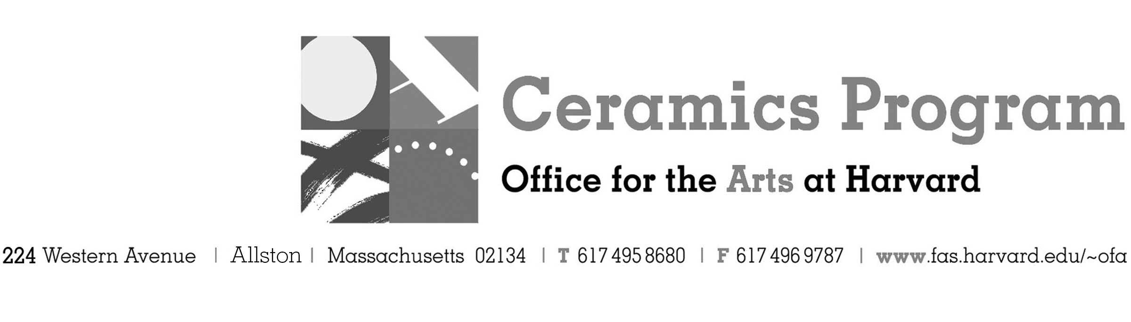

Master Class Workshop with Stuart Gair

Summer Term 2018

Workshop Dates Saturday, July 21st and Sunday, July 22nd 10am – 5pm each day

Fees Enrolled in a course and Harvard Graduate Students, $150. Not enrolled, $200. Free for Harvard Undergraduate Students.

Description Ready for a challenge? Join 2017-2018 Artist in Residence Stuart Gair in approaching three challenging forms for the intermediate to advanced thrower – the teapot, the pitcher and the batter bowl. Consideration to form, attached handles and spouts will be discussed and feedback on examples of work brought in by participants provided. This workshop is intended for those who have a proficiency in throwing on the wheel. Demonstrations of each form will be provided with work time for participants to throw on the wheel and apply what they have learned. Gair will provide a lecture on his own work and development of the forms being discussed. The cost of the workshop includes clay and bisque-firing work made during the workshop. Participants will be asked to bring a pot-luck item each day for lunch. Enrollment is limited to 20 participants.

- Make check or money order for workshop fees payable to Harvard University.
- Send or bring this registration form, payment and a TAP form if applicable, to the studio:
Ceramics Program, Visiting Artist Workshop, 224 Western Ave. Allston, MA 02134

Workshop | Total Fee
Stuart Gair Master Class for Potters | $
 | $
Workshop Fee | $

Contact Name (please print)
Address City
State Zip E-mail Address
Telephone (day) (cell)
Enrolled in a class Not enrolled in a class LACS Member
Harvard Employee: TAP eligible: regular Long service not TAP eligible
Harvard: Undergraduate Graduate Class of____ School/ Depart. at Harvard: ________________
Harvard Affiliation: Alum Extension School Student Spouse of Harvard Employee

for studio use only: Date received Check # Amount $ TAP form

