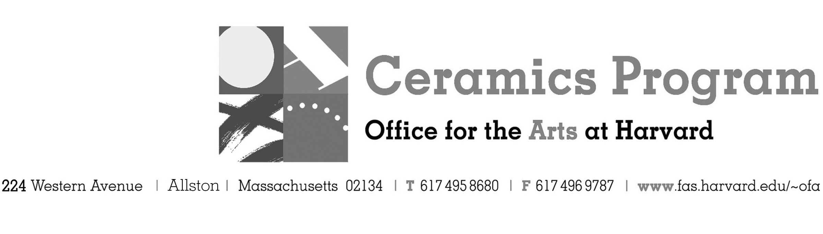

Visiting Artist Workshop: Walter Keeler

Spring Term 2018

Workshop Dates

Fees Enrolled in a course, $100. Not enrolled, $150. Harvard Graduate, $50. Free for Harvard Undergraduate Students.

Description We are honored to welcome UK potter, Walter Keeler, back to the Ceramics Program for a workshop dedicated to long-time Ceramics Program student and friend of Keeler - Terry Hass. Keeler stated, "I love giving workshops, but this one is very special, it is for Terry - loved by all of us - and will celebrate her love of making pottery, her warmth and generosity of spirit." All proceeds from the event will go to fund scholarships to the Ceramics Program in Terry's name.

This workshop will feature a pot-luck lunch associated with the event. Please bring a dish!

- Make check or money order for workshop fees payable to Harvard University.
- Send or bring this registration form, payment and a TAP form if applicable, to the studio:
Ceramics Program, Visiting Artist Workshop, 224 Western Ave. Allston, MA 02134

Workshop | Total Fee
Walter Keeler – Terry Hass Memorial Workshop | $
 | $
Workshop Fee | $

Contact Name (please print)
Address City
State Zip E-mail Address
Telephone (day) (cell)
Enrolled in a class Not enrolled in a class
Harvard Employee: TAP eligible: regular Long service not TAP eligible
Harvard: Undergraduate Graduate Class of____ School/ Depart. at Harvard: _________________
Harvard Affiliation: Alum Extension School Student Spouse of Harvard Employee

for studio use only: Date received Check # Amount $ TAP form

