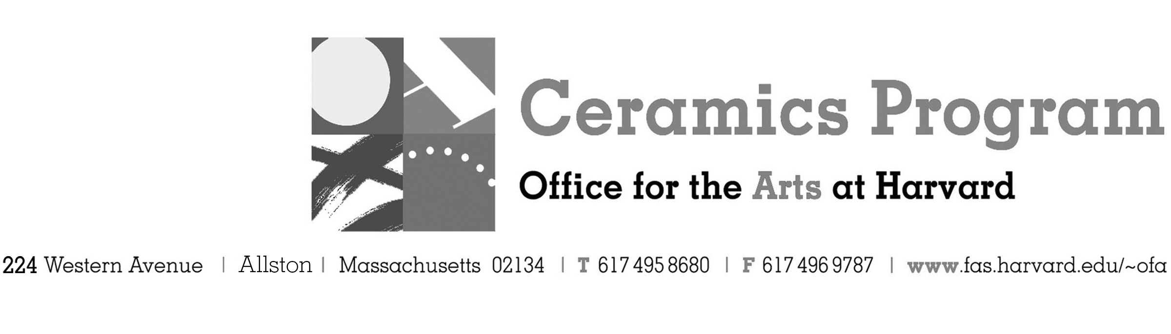

Visiting Artist Workshop: Michelle Gregor

Spring Term 2018

Workshop Dates Monday, March 19th, 6pm – 9pm

Fees Enrolled in a course, $25. Not enrolled, $50. Harvard Graduate, $25. Free for Harvard Undergraduate Students.

Description Join us in welcoming San Francisco Bay Area artist Michelle Gregor to the studio for a demonstration of her construction methods used in her abstracted human figure sculpture. Gregor will also provide a lecture of her body of work including both painterly ceramic and bronze figures.

- Make check or money order for workshop fees payable to Harvard University.
- Send or bring this registration form, payment and a TAP form if applicable, to the studio:
Ceramics Program, Visiting Artist Workshop, 224 Western Ave. Allston, MA 02134

Workshop | Total Fee
Michelle Gregor Workshop and Lecture | $
 | $
Workshop Fee | $

Contact Name (please print)
Address City
State Zip E-mail Address
Telephone (day) (cell)
Enrolled in a class Not enrolled in a class
Harvard Employee: TAP eligible: regular Long service not TAP eligible
Harvard: Undergraduate Graduate Class of____ School/ Depart. at Harvard: _________________
Harvard Affiliation: Alum Extension School Student Spouse of Harvard Employee

for studio use only: Date received Check # Amount $ TAP form

