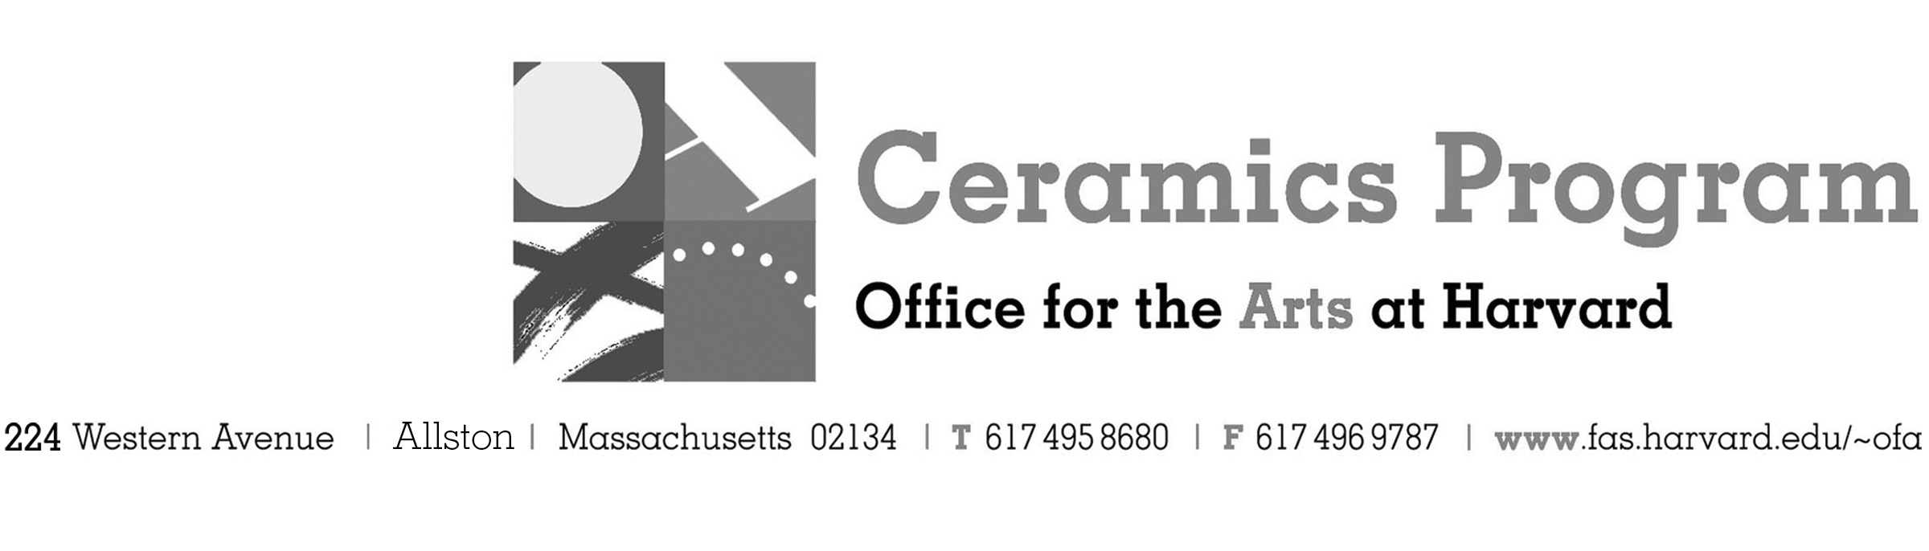

Visiting Artist Workshop: Sunshine Cobb and Jason Burnett

Spring Term 2018

Workshop Dates Saturday, April 7th and Sunday, April 8th 10am – 4pm each day

Fees Enrolled in a course, $125. Not enrolled, $200. Harvard Graduate, $50. Free for Harvard Undergraduate Students.

Description Join us in welcoming Jason Bige Burnett and Sunshine Cobb to explore a range of surface treatments while sharing stories and their experiences as contemporary ceramic artists. Whether your work is functional or sculptural, this workshop will provide you with a chance to explore, experiment and learn. Participants will have the opportunity to try their hand at the various techniques covered in the workshop and receive feedback from other participants and the workshop leaders.

This workshop will feature a pot-luck lunch from 1-2pm each day.

- Make check or money order for workshop fees payable to Harvard University.
- Send or bring this registration form, payment and a TAP form if applicable, to the studio:
Ceramics Program, Visiting Artist Workshop, 224 Western Ave. Allston, MA 02134

Workshop | Total Fee
Sunshine Cobb and Jason Burnett | $
 | $
Workshop Fee | $

Contact Name (please print)
Address City
State Zip E-mail Address
Telephone (day) (cell)
Enrolled in a class Not enrolled in a class
Harvard Employee: TAP eligible: regular Long service not TAP eligible
Harvard: Undergraduate Graduate Class of____ School/ Depart. at Harvard: _________________
Harvard Affiliation: Alum Extension School Student Spouse of Harvard Employee

for studio use only: Date received Check # Amount $ TAP form

