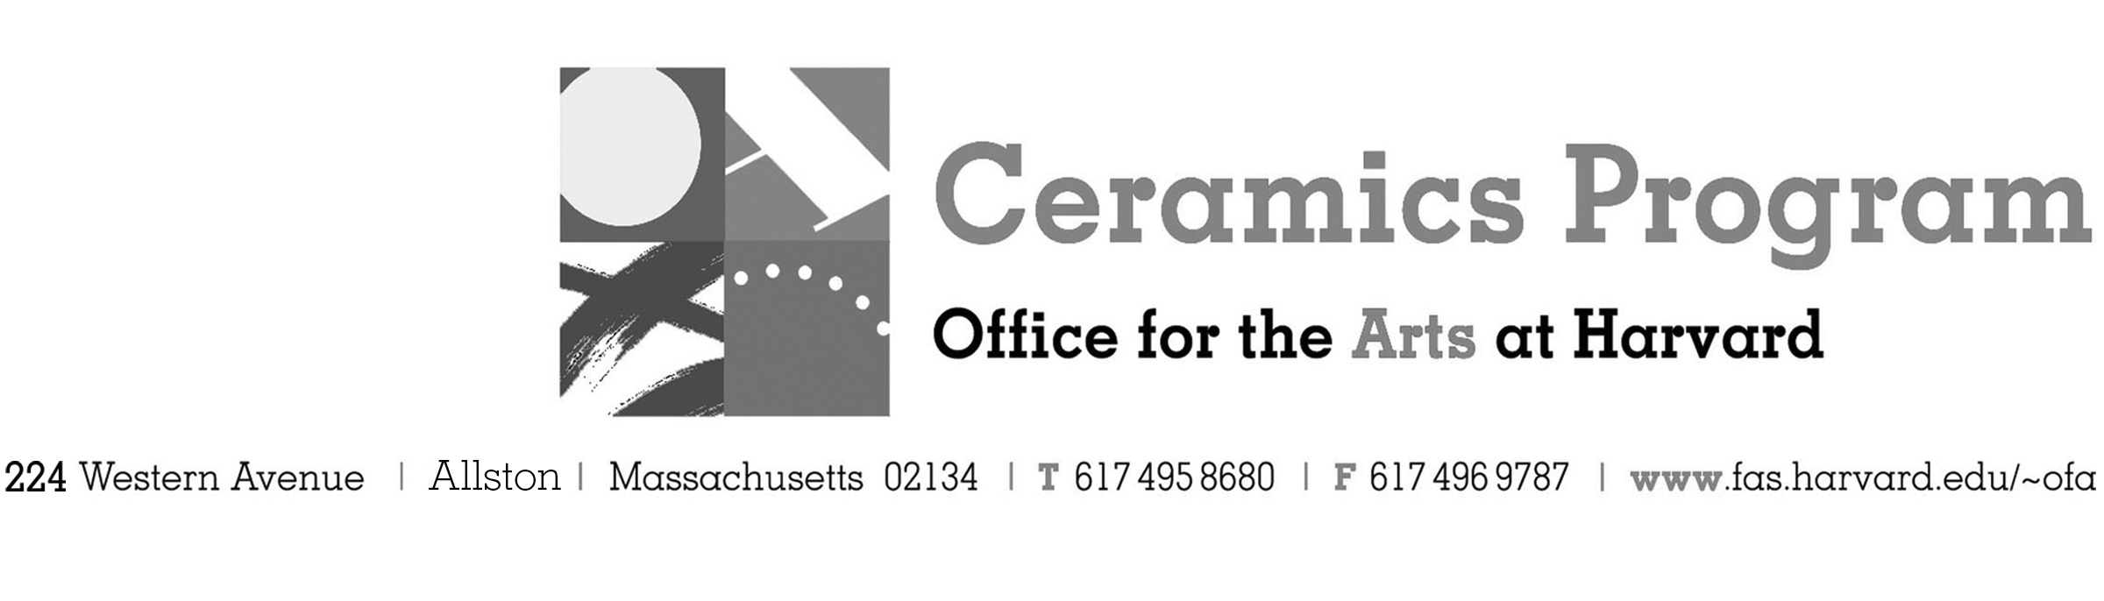

Visiting Artist Demonstration with Ben Owen III

Spring Term 2018

Workshop Dates Thursday, February 1st 1pm – 4pm with a slide presentation 5pm – 6pm

Fees Enrolled in a course, $20. Not enrolled, $50. Free for Harvard Undergraduate and Graduate Students.

Description Join us in welcoming master potter Ben Owen III for a half-day demonstration of his throwing process and lecture on his work and his role within the lineage of makers from Seagrove, North Carolina. This event, in part, celebrates the exhibition of his work at Pucker Gallery.

- Make check or money order for workshop fees payable to Harvard University.
- Send or bring this registration form, payment and a TAP form if applicable, to the studio:
Ceramics Program, Visiting Artist Workshop, 224 Western Ave. Allston, MA 02134

Workshop | Total Fee
Ben Owen III Visiting Artist Demonstration | $
 | $
Workshop Fee | $

Contact Name (please print)
Address City
State Zip E-mail Address
Telephone (day) (cell)
Enrolled in a class Not enrolled in a class
Harvard Employee: TAP eligible: regular Long service not TAP eligible
Harvard: Undergraduate Graduate Class of____ School/ Depart. at Harvard: _________________
Harvard Affiliation: Alum Extension School Student Spouse of Harvard Employee

for studio use only: Date received Check # Amount $ TAP form

