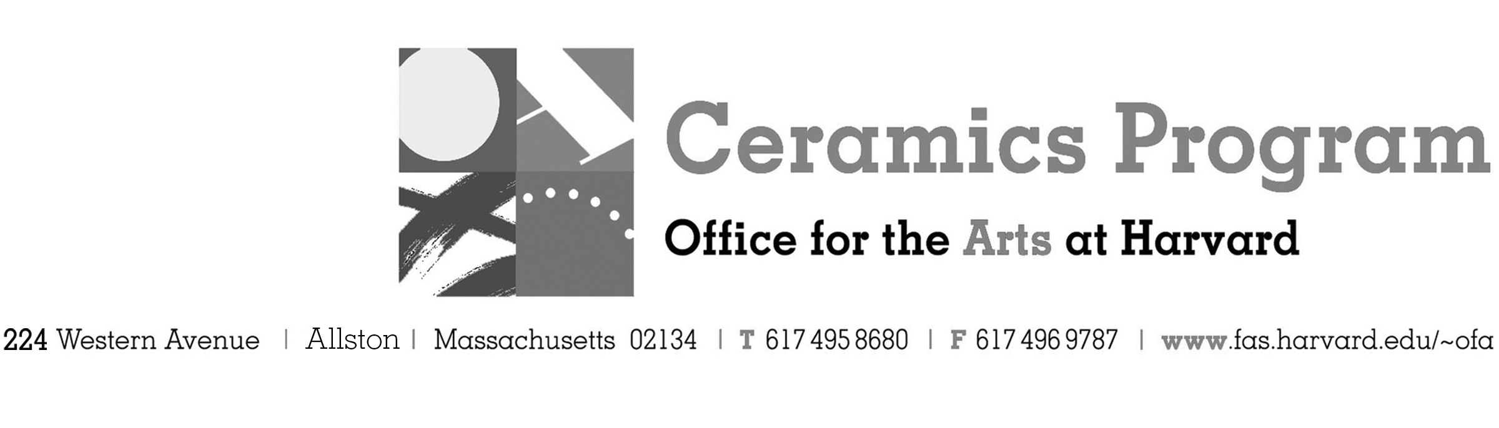

Visiting Artist Workshop: John Oles

Spring Term 2017 14-week term: January 30 – May 6, 2017

Workshop Date Friday, April 21, 10:00 am – 5:00pm

Fees Enrolled in a course, $75. Not enrolled, $125. Harvard Graduate, $50. Free for Harvard Undergraduate Students.

Description This workshop is designed for those who seek to expand their vocabulary of ceramic forms and techniques, break out of a rut, or inject some new energy into an uninspired studio practice. We will explore techniques used to create wheel thrown and altered pieces based on traditional pottery forms, combined with hand built elements to construct unique functional and sculptural vessels in porcelain. Techniques as stretching, altering and darting, and the use of found objects to apply texture. Throughout the workshop, participants are encouraged to engage in an open dialogue and presentation of sources of inspiration, as well as the significance of the hand mode object in the context of contemporary material culture.

Total registration fee and Harvard employee TAP form, if used, must be submitted with the registration form. We can accept payment in cash, check or money order. We do not accept credit cards.

- Make check or money order for workshop fees payable to Harvard University.
- Send or bring this registration form, payment and a TAP form if applicable, to the studio:
Ceramics Program, Visiting Artist Workshop, 224 Western Ave. Allston, MA 02134

Workshop | Total Fee
John Oles Visiting Artist Workshop | $
 | $
Workshop Fee | $

Contact Name (please print)
Address City
State Zip E-mail Address
Telephone (day) (cell)
Enrolled in a class Not enrolled in a class
Harvard Employee: TAP eligible: regular Long service not TAP eligible
Harvard: Undergraduate Graduate Class of____ School/ Depart. at Harvard: _________________
Harvard Affiliation: Alum Extension School Student Spouse of Harvard Employee

for studio use only: Date received Check # Amount $ TAP form

