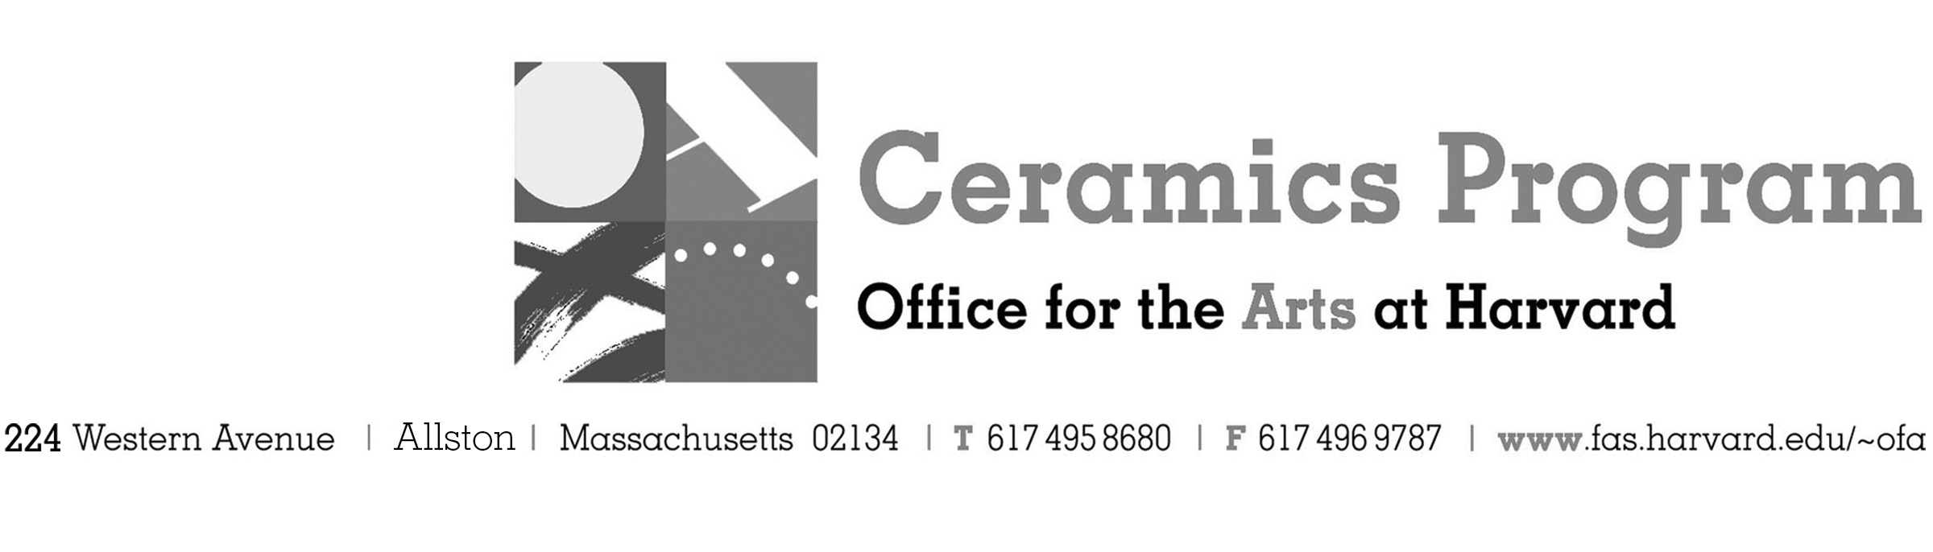

Visiting Artist Workshop: Shozo Michikawa

SU Term 2017 11-week term: May 30 – August 12, 2017

Workshop Dates Monday, June 5, 1:00 pm – 5:00pm

Fees Enrolled in a course, $65. Not enrolled, $85. Harvard Graduate, $40. Free for Harvard Undergraduates.

Description Join us in welcoming Michikawa to Boston for his solo exhibition with Lacoste Gallery. Michikawa has exhibited extensively in Japan and around the world, including London, Berlin and New York, the Philippines, Mongolia, France and China. The artist will provide a half-day demonstration of his art making process beginning at 1:00pm. The day will conclude with a slide lecture of his work at 5:00pm. Michikawa is hugely inspired by the power and energy of nature in its every form. It is his belief that nature would ultimately triumph over science and civilizations.

Total registration fee and Harvard employee TAP form, if used, must be submitted with the registration form. We can accept payment in cash, check or money order. We do not accept credit cards.
- Make check or money order for workshop fees payable to Harvard University.
- Send or bring this registration form, payment and a TAP form if applicable, to the studio:
Ceramics Program, Visiting Artist Workshop, 224 Western Ave. Allston, MA 02134

Workshop | Total Fee
Shozo Michikawa Visiting Artist Workshop | $
 | $
Workshop Fee | $

Contact Name (please print)
Address City
State Zip E-mail Address
Telephone (day) (cell)
Enrolled in a class Not enrolled in a class
Harvard Employee: TAP eligible: regular Long service not TAP eligible
Harvard: Undergraduate Graduate Class of____ School/ Depart. at Harvard: _________________
Harvard Affiliation: Alum Extension School Student Spouse of Harvard Employee

for studio use only: Date received Check # Amount $ TAP form

