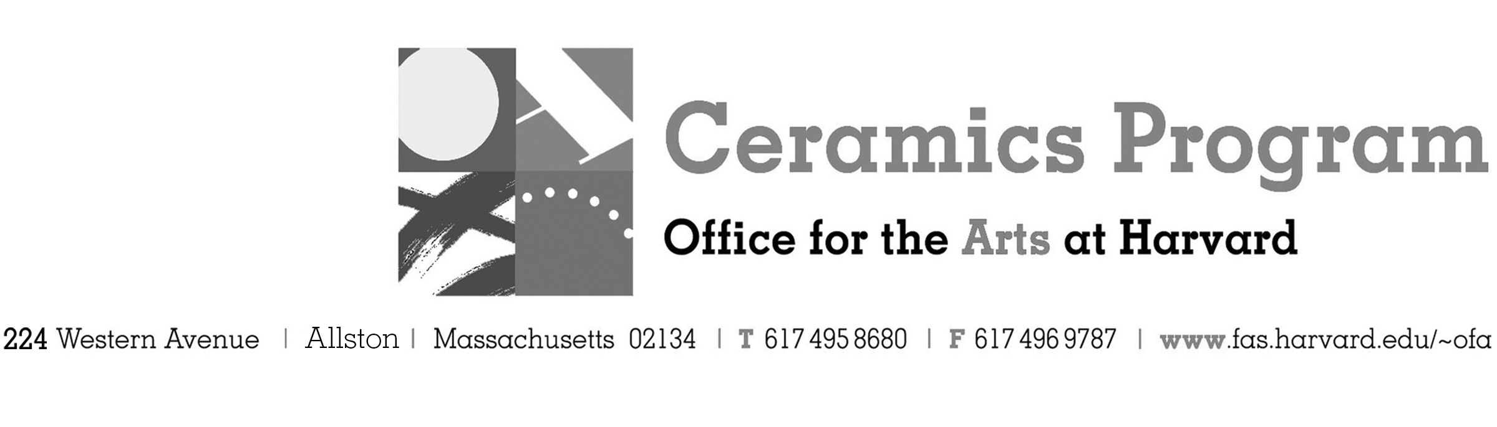

Visiting Artist Workshop: Michael Kline

Spring Term 2017 14-week term: January 30 – May 6, 2017

Workshop Dates Saturday, February 11, 10:00 am – 5:00pm

Fees Enrolled in a course, $75. Not enrolled, $125. Harvard Graduate, $50. Free for Harvard Undergraduate Students.

Description North Carolina master potter, Michael Kline, will demonstrate his beautifully thrown multi-part pots, handled bowls, jug forms and a cut-edge plate. Surface demonstrations will include brush-work with pigmented wax resist and slip-inlay techniques. Participants will enjoy a hands-on exercise on brush work. The day will include an hour for lunch (pot-luck) with a slide presentation on the Kline's work, his studio and kilns in North Carolina as well as his use of social media as a contemporary potter.

Total registration fee and Harvard employee TAP form, if used, must be submitted with the registration form. We can accept payment in cash, check or money order. We do not accept credit cards.

- Make check or money order for workshop fees payable to Harvard University.
- Send or bring this registration form, payment and a TAP form if applicable, to the studio:
Ceramics Program, Visiting Artist Workshop, 224 Western Ave. Allston, MA 02134

Workshop | Total Fee
Michael Kline Visiting Artist Workshop | $
 | $
Workshop Fee | $

Contact Name (please print)
Address City
State Zip E-mail Address
Telephone (day) (cell)
Enrolled in a class Not enrolled in a class
Harvard Employee: TAP eligible: regular Long service not TAP eligible
Harvard: Undergraduate Graduate Class of____ School/ Depart. at Harvard: _________________
Harvard Affiliation: Alum Extension School Student Spouse of Harvard Employee

for studio use only: Date received Check # Amount $ TAP form

